DS 620 Machine Learning and Deep Learning
HOS08Aa: TensorFlow Low-level
03/25/2024 Reviewed by Sherin Aly
16/05/2024 Reviewed by Naveena Moddu
08/21/2025 Reviewed by Ashwin Paturi
10/30/2025 Reviewed by Kina Anh Bui

School of Technology & Computing (STC) @ City University of Seattle (CityU)

Before You Start
- The directory path shown in screenshots may be different from yours.
- The document uses Google Collaboratory as the default compiler. If you want to run the code on a local machine, you need to configure the environment on your own.
- Some steps are not explained in the tutorial. If you are not sure what to do:
  - Consult the resources listed below.
  - If you cannot solve the problem after a few tries, ask a TA for help.

Learning objectives
- Lower-level Python API
- TensorFlow Keras
- TensorFlow Data API
- Custom model and training algorithms

Resources
- Gadosey, P. (2019, August 19). A beginner’s guide to NumPy with Sigmoid, ReLu and Softmax activation functions. Medium. https://medium.com/ai%C2%B3-theory-practice-business/a-beginners-guide-to-numpy-with-sigmoid-relu-and-softmax-activation-functions-25b840a9a272
- Géron, A. (2019). Hands-on machine learning with scikit-learn, keras, and tensorflow (2nd ed.). O’Reilly Media.
- Jeffries, D. (2021, November 25). Learning AI if You Suck at Math -Part 4- Tensors Illustrated (with Cats!). Experfy. https://resources.experfy.com/ai-ml/learning-ai-if-you-suck-at-math-part4-tensors-illustrated-with-cats/

Introduction
So far, what we have learned from TensorFlow utilizes high-level APIs. Most of the operations were implemented with a single line of code, such as passing a value to the function’s parameter (e.g., loss function, activation function, optimizer, regularizer, weight initializer, etc.). Up until now, most of these algorithms have been a black box, and we have not had the flexibility to customize these algorithms on our own. In this HOS, we will dive deeper into TensorFlow, dissecting its components and learning how to build these algorithms on our own. Some of the code in this exercise can be found in Hands-On Machine Learning with Scikit-Learn, Keras, and TensorFlow (Géron, 2019).

Import Libraries
- Go to https://colab.research.google.com. Create a new notebook and name it “Tensorflow.ipynb”.
- Now, we need to import the necessary libraries. Type the following in your code cell, then click the play button or Ctrl + Enter to run the cell.

Tensor: A tensor is the fundamental data structure that powers TensorFlow. It is so crucial that its name is part of TensorFlow itself. So, what is a tensor? As we have reviewed before, tensors are essentially multi-dimensional arrays. Like a regular Python array, a tensor contains numerical values, and the number of dimensions can be as many as you set it to be.
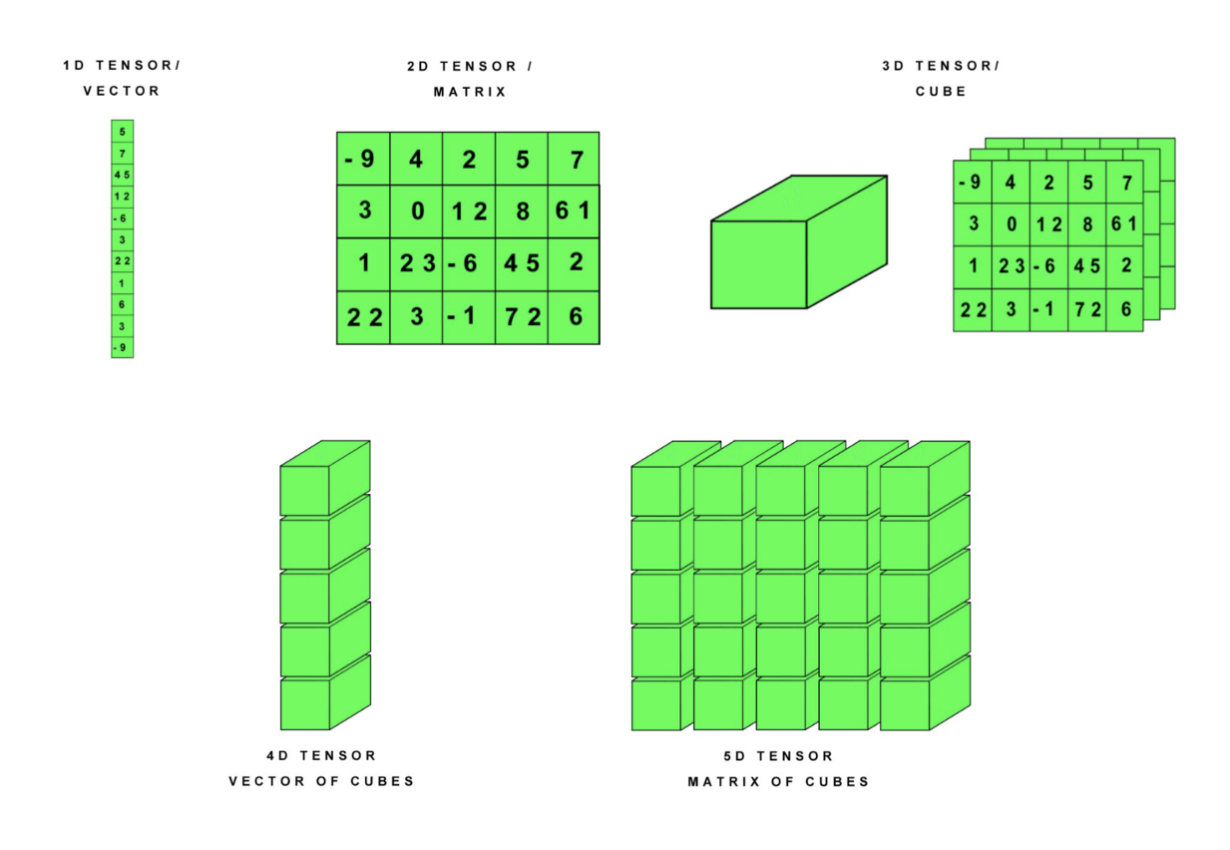
Figure 1: 1D to 5D Tensor Examples (Jeffries, 2021)
- We will start by building a matrix tensor. A tensor works precisely like a NumPy array. In fact, you can convert a tensor into a NumPy array. Click the + Code button to add new code cells. Type the following code in the cells, then click the play button or Ctrl + Enter to run them.

- Tensor arithmetic operations are very similar to NumPy as well. Click the + Code button to add new code cells. Type the following code in the cells, then click the play button or Ctrl + Enter to run them.

Custom Activation Functions: The activation function determines whether a neuron is active or inactive. Its name is inspired by how the neuron in our brain is “activated” by different stimuli. It takes in the weighted sum and bias of the previous layer and outputs a value. The activation function is essentially the soul of the neural network because it provides the nonlinear factors for the network. The linear factor, brought by the weights and biases, and the nonlinear factor, brought by the activation function, give the possibility of fitting arbitrary relations to the neural network. In addition, the activation function also constrains the model output results.

Next, we will implement custom activation functions for the most common activation functions: relu, sigmoid, softmax, and softplus.

- Click the + Code button to add a new code cell. Type the following code in the cell, then click the play button or Ctrl + Enter to run the cell.

Custom Loss Functions: The loss function describes the difference between the predicted and actual values of the model. Usually, we refer to this difference as an error or a loss. Since the loss shows the relationship between the predicted value and the actual value, and the predicted value is closely related to the parameters of the model, we can optimize our model parameters based on the loss function. The more different the predicted value is from the actual value, the larger the output of the loss function is, which gives the model a target value to minimize during the training process.

- Let us implement an example of mean squared error, which is the most common regression loss function. It comprises only two inputs, the predicted value and the true value. Click the + Code button to add a new code cell. Type the following code in the cell, then click the play button or Ctrl + Enter to run the cell.

- When the function requires a hyperparameter, which is an input other than the predicted value and the true value, an object-oriented approach is required, as this ensures that the hyperparameter will be saved. An advantage of using this approach is that you can inherit directly from the parent class in Keras. Click the + Code button to add a new code cell. Type the following code in the cell, then click the play button or Ctrl + Enter to run the cell.

Custom Regularizer: When training a dataset, the model learns the underlying pattern of the sample dataset, aiming to estimate the actual pattern of the population. However, when the model learns too much from the pattern of the training data set, it risks missing the exact pattern of the population, thus resulting in an overfitted model because not all training data is a reasonable estimate of the population. The goal of regularization is to prevent the model from overfitting. This is achieved by reducing the model's weight by a factor.

- First, we will implement a custom regularizer using a functional programming approach. As mentioned above, the factor will not be saved using this approach. Click the + Code button to add a new code cell. Type the following code in the cell, then click the play button or Ctrl + Enter to run the cell.

- Next, we will implement an example using an OOP approach. Click the + Code button to add a new code cell. Type the following code in the cell, then click the play button or Ctrl + Enter to run the cell.

Custom Layer: Sometimes, the situation may require you to build your own layer. You can only create a layer using the Object-Oriented Approach, as there are hyperparameters that need to be saved before using the layer.

- We will implement a simplified version of the Dense layer. Click the + Code button to add a new code cell. Type the following code in the cell, then click the play button or Ctrl + Enter to run the cell.

Push your work to GitHub
- Click File → Download → Download .ipynb.
- The file will be downloaded to your Download folder (or another folder according to your browser settings).
- Move the downloaded ipynb file to your Module08 folder.
- Follow the instructions on the CityU STC TA Center Github.io Submit your work page.

